 | The National Program  FACULTY for FACTORY | 

Study of Exploration and Characterization of
Zeolitic Tuff (ZT) Minerals

FFF Final Project Report

Project Title  (in arabic and english) | Characterization of Pozzolana from Tafila Area and its Potential use as Agricultural Material for Plant Growth.  خصائص البوزولانا من منطقة الطفيلة وامكانية استخدامها كمواد زراعية لنمو النباتات
Participant Name  (in arabic and english) | Dr. Reyad Ali S. Al Dwairi  د. رياض علي سلمان الدويري
Company Name  (in arabic and english) | The Great Company of Mining and Agriculture  الشركة العظمى للتعدين والزراعة
Sponsor | FACULTY for FACTORY Program  The Great Company of Mining and Agriculture

Date: 15/11/2013

- Abstract
Huge quantities of volcanic tuff (VT) (Pozzolana) deposits are available in Tafila area. Al- Hala Volcano (HV) is one of the biggest deposits for VT located in southern Jordan which was chosen in this study. Exploration and characterization of zeolitic tuff (ZT) minerals is the main goal of this study in addition to the agricultural application for possible usage as soil amendment and improvement. Exploration studies indicate that VT is highly altered to ZT due to percolating alkaline water. ZT is characterized by highly weathered, friable and range in color according to zeolitization process and chemical composition to many different colors. The three main ZT types are reddish (RZT), brownish (BZT) and grayish (GZT). Mineralogical studies indicate that VT is composed mainly of three mineral components: Volcanic glass (palagonit), primary rock forming minerals (Idingsite and Diobside) and secondary rock forming minerals (zeolites, calcite and clay minerals). The main zeolites minerals in HV are phillipsite and chabazite. The ZT from HV shows acceptable pH with high cation exchange capacity range from (189 meq/100gm) for RZT to (136 meq/gm) for GZT. Geochemical studies indicate that ZT from HV has low Na₂O% ranges between (0.34 %) and (1.44%) with a high percentage of important oxides such as Ca, Mg, K, Mn, and Al. The type of Tafila Soli (TS) is silty clay texture which considered as heavy soil as indicated by size fractionation analysis results.
The ZT from HV is evaluated for agricultural applications by using RZT and GZT as soil amendments for planting tomatoes and pepper vegetables. The mixture with the ratio of 50:50 TS:RZT results shows increasing in terms of growth, yield and roots assemblages for both vegetables.

- Introduction and background
The Great Company of Mining and Agriculture (GC) plans to be the main leader in Jordan for supplying agricultural soil, soil amendment and soil conditioners. The factory belongs to GC produces Pozzolana and Clay minerals as raw materials for cement industry in the south of Jordan. Pozzolana is the commercial name of the igneous rocks named volcanic tuff (VT). The mineral content of VT varies from geological bed to another bed based on the weathering rate and zeolitization processes which reflect the quantity of secondary minerals associated with volcanic tuff. Zeolites are the most important minerals associated with volcanic tuff, so the name of the volcanic tuff enriched with zeolites is zeolitic volcanic tuff or zeolitic tuff (ZT).
Zeolites are hydrated aluminum silicate framework in which its structure contains channels or pores filled with exchangeable cations and some percentage of water (Mumpton 1978). They characterized by availability, low coast, high ion exchange capacity, excellent adsorption properties and slow release fertilizers. Such important properties make zeolites a good solution as a natural alternative of other used soil fertilizers and amendments. Identification of zeolite as a mineral goes back to 1756, by the Swedish mineralogist, Fredrich Cronstet (Gottardi, 1978). In the world, their commercial production and use started in 1960s, but in Jordan they were discovered for the first time in 1987 by Dwairi in north east area (Arytain Volcano). Jordan has important zeolitic tuff production potentials and reserves that cover large areas that are distributed in three main locations north east, central and south Jordan (Al Dwairi 2007).
The application of natural zeolitic tuff as soil conditioner and fertilizer has known by the Japanese for over a hundred year. Mumpton (1985) discussed the zeolite potential for the use as a source for slow-release of fertilizers such as N and K. The zeolitic tuff (soil conditioners) is also used to reduce the agriculture pollution.
In Jordan zeolites, ZT, and VT have been studied widely for their mineralogy petrology and their environmental applications. The most important studies were carried out by Dwairi (1987), who was the first to discover zeolites in Jabal Aritain, and Ibrahim (1993), who accomplished a lot of mapping, geological and geochemical work.
Jordanian phillipsitic tuff of Aritain area was suggested for a possible us as a soil amendments (conditioner) in agriculture (Reshiedat, 1991), furthermore Dwairi (1998) used the zeolitic phillipsite tuff from Aritain area as slow release fertilizer he evaluated the exchange and release properties of the natural phillipsite tuff by studying the exchange properties of this natural zeolite in the NH4–Na system. Ghrir (1998) has evaluated the Jordanian Phillipsitic tuff from Aritain (north east Jordan) and Mukawer (Central Jordan) in agriculture as soil conditioner for planting strawberry under green houses.
Manolov, et al (2005) used Jordanian zeolitic tuff from Aritain (north east Jordan) as raw material for the preparation of substrates used for plant growth. The research study concluded that the Jordanian zeolitic tuff has specific properties – high CEC, high content of macro and microelements which makes them one of good alternatives to the traditional potting media. Al Dwairi (2007) reported new occurrences in the northeast, central, and south of Jordan. The research explored and studied the characterization (mineralogy, petrology and geochemistry) of all possible locations of volcanic tuff in Jordan. Also, in (2009) Al Dwairi studied the mineralogy and authigenesis of zeolitic tuff from Tall-Juhira and Tall Amir, in the south of Jordan.
The soil of Tafila (TS) area is very poor in terms of minerals necessary for plants growth and also the rainfall percentage is very low, consequently zeolites as a soil conditioner can play a significant role in improving the soil characterization which will be reflected upon agricultural production.

Tafila area considered as arid to semiarid regions with a short rainy winter season with an average annual precipitation of 100 mm. The soil of Tafila Fig (1) characterized by soft grains, high porosity and low permeability, so this type of soil is called the heavy soil, consequently zeolites as a soil conditioner plays a significant role in improving the physical and chemical characterization of soil which will be reflected upon agricultural sector in Al Tafila.

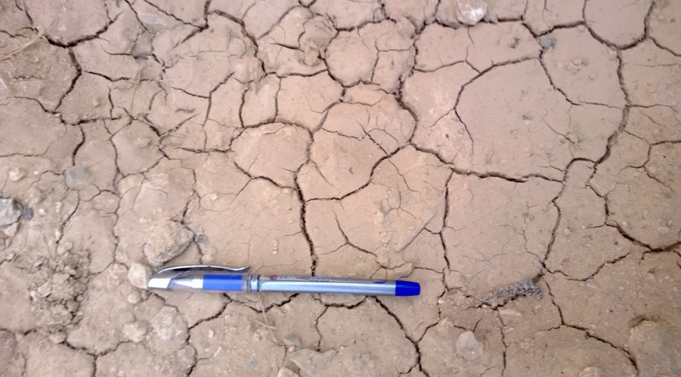
Figure (1) Soil from Al Eis area (Tafila)
To enhance and improve Tafila soil, this research proposes the ZT from HV to be mixed with these soils. There are huge amounts of zeolitic minerals in Al Hala Volcano (HV) (Figure 2) without investigation or characterization as agricultural fertilizes and amendments. The main problem is the lack of information about these zeolites and their mineral content in HV. In addition to the promising future of using zeolite as agricultural soil conditioner. This encourages the GC and the present researcher to extend their production scope to include the soil conditioners and amendments.
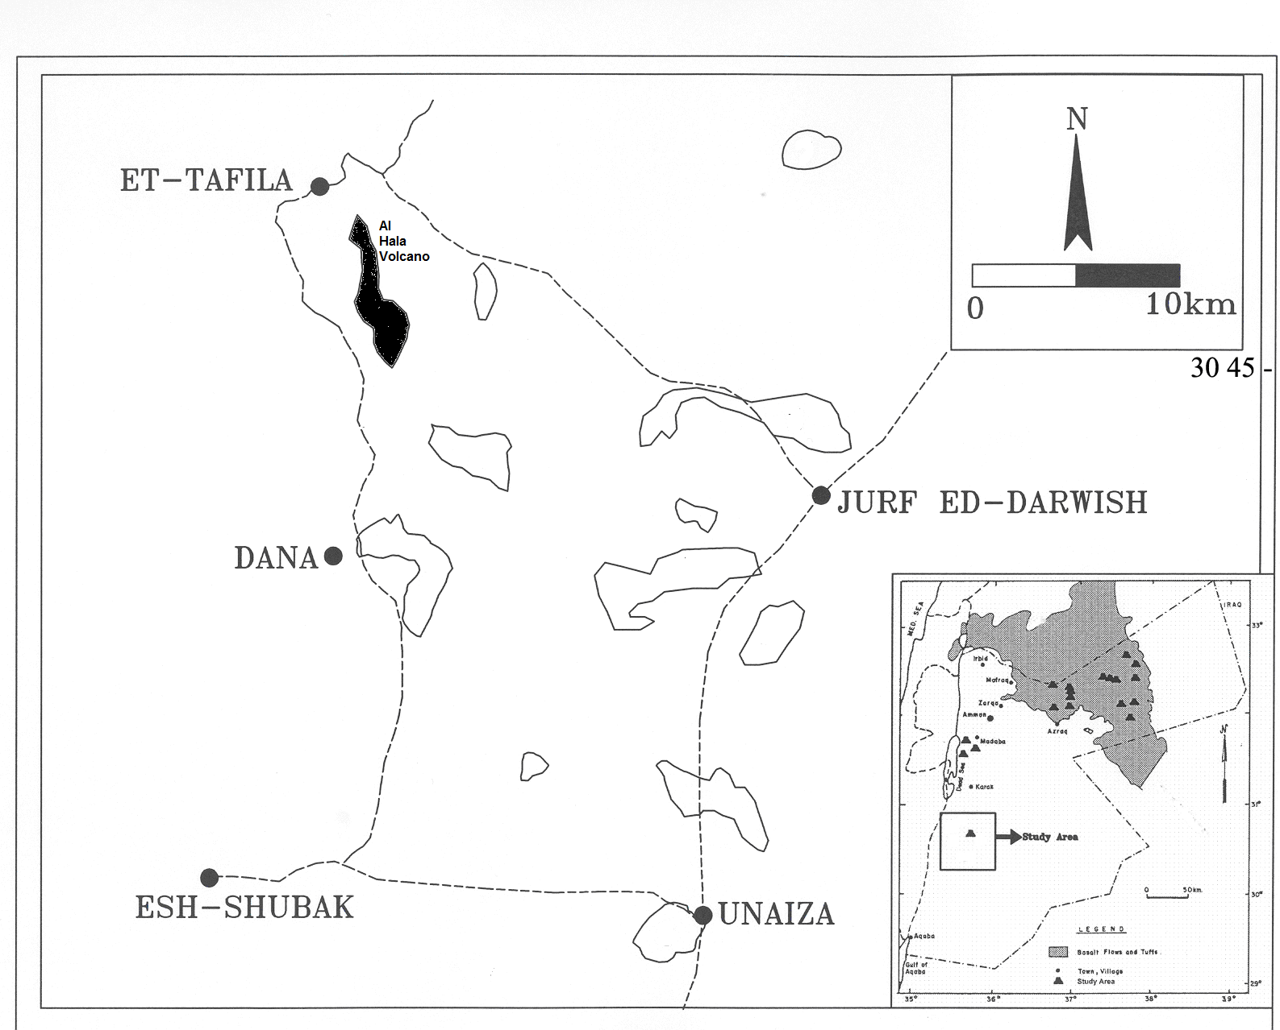
Figure (2) Location map of the southern Jordan basaltic tuff showing
Al-Hala Volcano (after Al Dwairi 2007).

- Objectives
- Exploration for zeolites and zeolitic tuff in HV, south Jordan
- Geological and agricultural characterization of the zeolites.
- Investigate the ability of using zeolites in agriculture to enhance the physical and chemical proprieties of Tafila soil by starting primary agricultural experiments.

- Methodology
Materials
The used material in this study is VT obtained from the GC quarry in HV. Six bulk samples (10 Kg) were collected from the quarry for the characterization analyses and two main bulk Samples (1 Ton) were chosen for the agricultural experiments, Table (1). The grain size fraction (1-0.3mm) was used in the agricultural experiments because of the highest zeolitic content (Al Dwairi 2007). The used soil was collected locally from Al Eis area (TS).

Table (1) Sampling and the used laboratory techniques.
# | Type | Color | Thin section | XRD | SEM | XRF | Agricultural application
1 | RZT1 | Reddish | X | X | X | X | X
2 | BZT2 | Brownish | X | X | X | X
3 | LBZT3 | Light Brown | X | X | X | X
4 | GZT4 | Grayish | X | X | X | X | X
5 | LGZT5 | Light gray | X | X | X | X
6 | VT6 | Black | X | X | X | X
7 | TS (Control) | Yalow to white | --- | --- | --- | X | X

Methods
The exploration of zeolites includes many exploration trips, sample collecting, cross section, and mapping. The characterization of the volcanic tuff will be carried out using different analytical methods including thin section, X Ray Diffraction (XRD), Scanning Electron Microscope (SEM), and X Ray Fluorescence (XRF) (Table 1). Finally the results will be studied and analyzed to evaluate the ability of using zeolites as soil amendment then to start a series of agricultural experiments by using mixtures of soil and zeolites with different ratios. The used soil was thoroughly characterized using chemical analysis, physical properties and grain size distribution.

Agricultural Experimental Setup
The Agricultural experimental setup was basically carried out by using RZT and GZT for a primary experiments as indicated in table (2) and figure (3). The area of agricultural experiment was divided into five equal area tubs (1m*1m). Tomato and Pepper were chosen as example for important vegetation in Jordan. 17/6/2013 was the starting day were the different tubs planted and 17/10/2103 was the end day. The irrigation program was carried out one time peer week for all tubs.
Table 2: Agricultural experiment setup parameters
Type | Grain size (mm) | Mixing Ratio  TS:ZT | Plant Name
RZT1 | 1-0.3 | 75:25 | Tomato+ Pepper
RZT2 | 1-0.3 | 50:50 | Tomato+ Pepper
GZT3 | 1-0.3 | 75:25 | Tomato+ Pepper
GZT4 | 1-0.3 | 50:50 | Tomato+ Pepper
TS | Normal | ----- | Tomato+ Pepper

RZT:TS  75:25 | GZT:TS  75:25 | Normal TS (Controlled Tub)  ( without mixing)
RZT:TS  50:50 | GZT:TS  50:50

Figure (3) Configuration for the agricultural experiments using tomato and pepper tubs.

- Results and Discussion
Zeolitic tuff Exploration Results
HV has a height of 1673m above the sea level. The exploration studies indicate that the VT has a thickness of (70m) with a reserve of 16 million tons. A soil bed was recognized on the top of the VT section with about 70 cm in thickness. The northern part of HV is an open mine for the GC.
The primary observation of the VT shows that the pyroclastics is highly altered to ZT due to the arid environment and alkaline percolating water. The field investigation and the lithological section shows that the VT is bad sorted, bad cemented, and dominated by large bombs. The VT cross section in the mine is characterized by the absence of bedding with a variety of vertical colors (red, brown, gray, and black) refers for the high alteration and weathering (Fig. 4). The natural zeolite in the area of discovery was formed by the reaction of volcanic glass with percolating alkaline water leading to provide a white gel rim of aluminum silicate (zeolite) filling the cavities of the volcanic tuff (Fig. 5)

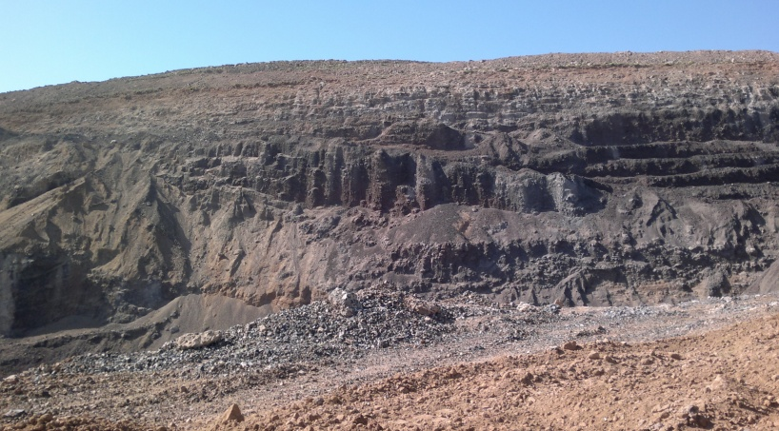
Figure (4) Cross section of VT in HV (The GC quarry).

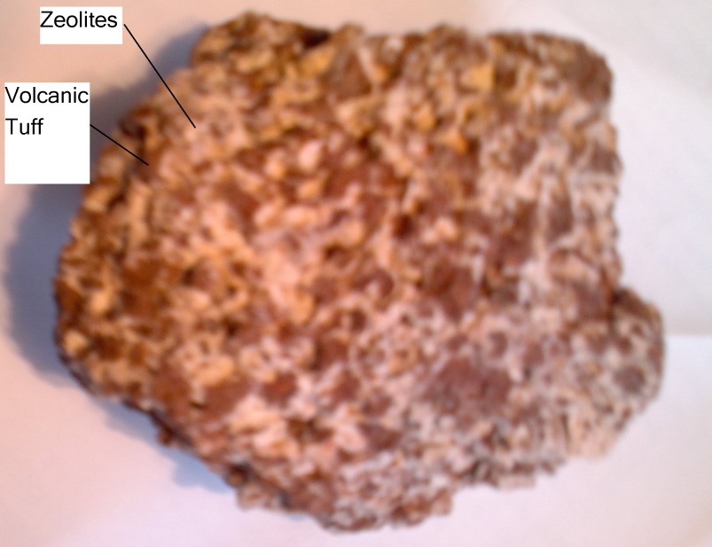
Figure (5) Reddish zeolitic tuff sample from HV.

Zeolitic Tuff Characterization Results
Thin section results indicate that VT is highly altered to ZT. Figure (6) shows that the ZT is composed of palagonite matrix, iron oxides, zeolites, clay minerals, and calcite.

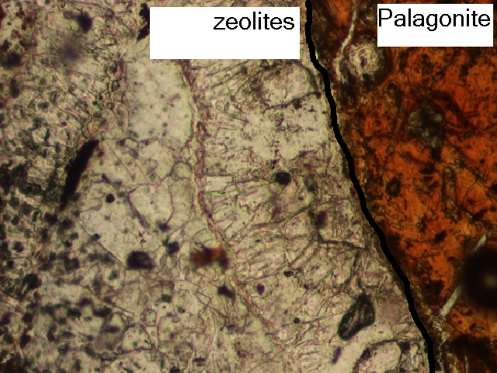
Figure (6) Thin section of VT from HV.

The surface morphology of ZT was examined by SEM and is presented in Figure 7.The figure shows assemblages of zeolite minerals such as phillipsite and chabazite in adition to clay minerals. The powder X Ray Diffraction (XRD) analysis (using Cu KR as the source for X-rays) of VT was performed for 10 samples from the GC quarry. The XRD patterns of VT are presented in Figure 8. The results show that the VT is composed of zeolitic minerals (Phillipsite and Chabazite) and non-zeolites (palagonite . smectite, iron oxides and Calcite).
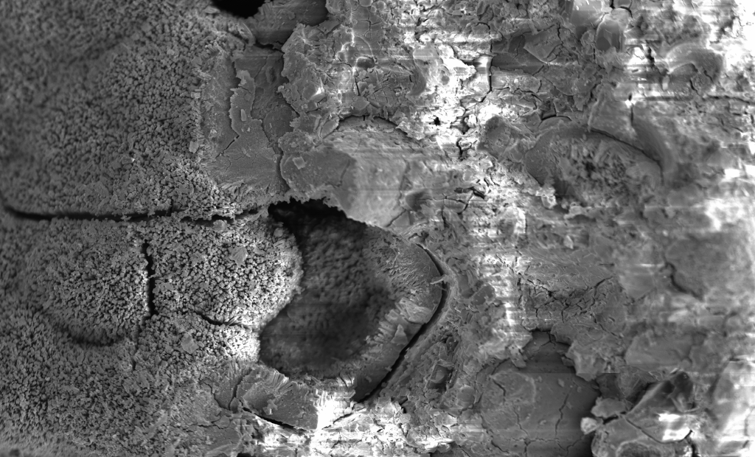
Figure (7) SEM for ZT from HV.

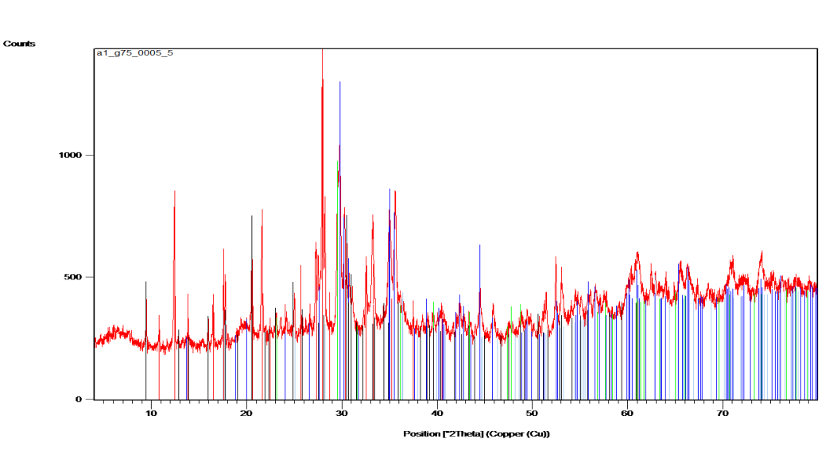
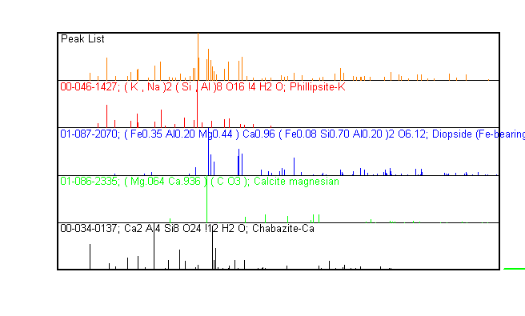
Figure (8) X-Ray Diffraction pattern for ZT from HV.

The chemical composition of black volcanic tuff (BVT), reddish zeolitic tuff (RZT) and grayish zeolitic tuff (GRT) are determined by using X Ray Flourcens (XRF) apparatus. The results are listed in table 3. The chemical analysis indicates that the ZT from HV contains many elements such as Mg, Mn, Ca, K and Al. Furthermore the silica percentage for the BVT is the highest with an average of (41%) and range between (42.10%) to (40.30%), while the lowest percentage was for the RZT with an average of (40%) and values range between (41.70) to (39.60).
The most important oxide in the agriculture issue is Na₂O₃. The results show very low percentage values for ZT ranging between (0.345%) and (0.67) with an average of (0.505), while it’s high in the BVT with an average of (3.575%) and values ranging between (4.12%) and (3.03%).
Ion exchange capacity (CEC) is an important property for zeolites to be used as an agricultural amendment. The three main zeolitic tuff types (RZT, BZT and GZT) from HV were subjected to the CEC measurements. The ZT were sieved into the grain size of (1-0.3) mm which has the highest zeolitic minerals content (Al Dwairi 2007). Table (4) shows the results of the CEC values expressed by meq/100gm. The ZT from HV has a high CEC. The highest CEC value is obtained for RZT (189), while the CEC for BZT is (132). The lowest value or CEC obtained was for GZT (118).

Table (3) Chemical composition (wt %) for volcanic tuff from HV
Color | Sample # | Sio₂ | Na₂O | Fe₂O₃ | MgO | Al₂O₃ | K₂O | CaO | MnO | TiO₂ | P₂O₃ | CO₂ | Sum
Reddish | RZT1 | 41.70 | 0.521 | 15.50 | 6.67 | 15.60 | 0.94 | 7.62 | 0.199 | 3.28 | 0.700 | 6.80 | 99.53
Reddish | RZT2 | 40.80 | 0.670 | 15.80 | 7.23 | 16.90 | 0.80 | 6.70 | 0.210 | 3.17 | 0.900 | 6.10 | 99.28
Reddish | RZT3 | 39.60 | 0.340 | 16.01 | 6.89 | 16.17 | 0.82 | 8.10 | 0.220 | 3.50 | 0.810 | 6.90 | 99.36
Grayish | GZT1 | 38.20 | 1.44 | 13.20 | 6.44 | 14.60 | 0.58 | 11.6 | 0.178 | 3.37 | 0.728 | 9.00 | 99.33
Grayish | GZT2 | 39.30 | 1.20 | 14.50 | 6.90 | 15.70 | 0.71 | 8.70 | 0.240 | 3.41 | 0.691 | 8.00 | 99.35
Grayish | GZT3 | 40.00 | 1.60 | 13.70 | 6.70 | 15.10 | 0.92 | 9.60 | 0.191 | 3.52 | 0.710 | 7.61 | 99.65
Black | BVT1 | 40.30 | 3.03 | 15.60 | 8.07 | 12.20 | 0.50 | 8.90 | 2.203 | 3.84 | 0.205 | 4.20 | 99.05
Black | BVT2 | 42.10 | 4.12 | 12.39 | 9.97 | 11.33 | 1.02 | 9.70 | 1.801 | 3.17 | 0.600 | 3.20 | 99.40
Black | BVT3 | 41.80 | 3.90 | 13.45 | 8.70 | 11.90 | 0.80 | 8.20 | 2.530 | 3.67 | 0.320 | 4.70 | 99.97

Table (4) The CEC values for (1-0.3mm) ZT from HV.
Color | Sample # | CEC  Meq/100gm | Average
Reddish | RZT1 | 167 | 170
Reddish | RZT2 | 175 | 170
Reddish | RZT3 | 189 | 170
Brownish | BZT1 | 132 | 129
Brownish | BZT2 | 127 | 129
Brownish | BZT3 | 129 | 129
Grayish | GZT1 | 118 | 115
Grayish | GZT2 | 115 | 115
Grayish | GZT3 | 113 | 115

Tafila soil characterization results
The various physical and chemical properties for Tafila soil are shown in Tables (5) and (6). The results of size distribution indicate that the clay size is the highest with a percentage ranges between (45.1) and (46.2), the silt size range between (45.3) and ( 42.8), and the sand size range between (9.0) and (11.2); according to sieve analysis the texture of this soil is silty clay. The chemical analysis shows a good percentage of CaCO₃ ranges between (27.6) and (26.1).

Table (5) The particle size distribution for TS
Size fraction | TS1 | TS2 | TS3
Sand | 9.1 | 10.2 | 10.3
Silt | 45.3 | 44.3 | 42.8
Clay | 45.1 | 45.2 | 46.2
Total | 99.5 | 99.7 | 99.3

Table (6) Physical and chemical characteristics of the Tafila soil (Al Eis area)
Oxides | TS at depth  10 cm | TS at depth  20 cm | TS at depth  30 cm
SiO₂ | 52.60 | 51.89 | 52.21
Na₂O | 0.41 | 0.37 | 0.31
Fe₂O₃ | 4.17 | 8.81 | 9.71
MgO | 2.77 | 3.10 | 3.51
Al₂O₃ | 8.12 | 7.98 | 8.52
K₂O | 1.48 | 1.55 | 1.68
CaO | 18.02 | 18.83 | 18.80
MnO | 0.07 | 0.06 | 0.06
TiO₂ | 0.71 | 0.76 | 0.78
pH | 7.7 | 7.7 | 7.7
EC | 1.30 | 0.96 | 0.81
CaCO₃% | 26.9 | 27.6 | 26.1

Agricultural Experiments Observation
The agricultural results expressed by using comparison between the different parameters (growing, yield and root assemblages) are carried out for different planted tubs ( Table 7). All the mixed ZT tubs compared with the controlled TS gave good results for improving different growing parameters. The primary experiments for tubs with the mixing ratio of 50: 50 TS: ZT show best results observed for tomato and pepper vegetables. The results of the majority of the agricultural experiments are shown in figures (9, 10, 11, 12, 13, 14, 15, 16, 17, and 18). More vegetables were planted using 50:50 TS:ZT. The figures are listed in appendix (1)
Table (7) The comparison between planted tubs after 3 moths planting.
Vegetables | Tub | Average plant height (cm) | Plant Root assemblages
Tomato | 50:50 TS:RZT | 1.32 | Long, distributed,
Tomato | 75:25 TS:RZT | 95 | Long, distributed,
Tomato | 50:50 TS:GZT | 1.12 | Long, distributed,
Tomato | 75:25 TS:GZT | 80 | Long, distributed,
Tomato | TS (Control) | 28 | Condense, short,
Pepper | 50:50 TS:RZT | 80 | Long, distributed,
Pepper | 75:25 TS:RZT | 50 | Long, distributed,
Pepper | 50:50 TS:GZT | 70 | Long, distributed,
Pepper | 75:25 TS:GZT | 45 | Long, distributed,
Pepper | TS (Control) | 20 | Condense, Short,
- Conclusions and Recommendations
The Jordanian natural ZT from HV is suitable for agricultural applications due to its low Na₂O %, high cation exchange, suitable mineral content, and stable pH. ZT is therefore used to promote better plant growth by improving the value of fertilizers. They retain valuable plant growth and improve the quality of the soil and can also be used as a slow release fertilizer or a soil amendment. When applying ZT to agricultural production, one should emphasize that their natural source suitable and is of uniform characteristics and unique properties such as cation exchange capacity, pH, and Na content.
The results of this study strongly suggest the use of ZT from HV as a soil amendment to improve the soil properties. Also, more preparation and processing for ZT are recommended. For wide application in the agricultural sector a production of agricultural commodity is needed.
For the sake of commercial purpose, extensive research that pertains agricultural experiments using mixtures of soil and zeolites is highly needed and recommended.

- Acknowledgement
The author expresses special thanks to Mr. Mousa Al Qaisi, the manager of The GC for his assistant and support. Also, the author is deeply grateful for the staff of the GC for their corporation and help.

- References
- Al Dwairi, R. (2007). Characterization of the Jordanian zeolitic tuff and its potential use in Khirbet es Samra wastewater treatment plant. PhD Thesis, The University of Jordan, Amman, Jordan. 185 P.
- Al Dwairi, R., Khoury, H., and Ibrahim, K., (2009): Mineralogy and Authigenesis of Zeolitic Tuff from Tall-Juhira and Tall Amir, South Jordan, Jordan Journal of Earth and Environmental Sciences, Volume 2, Number 2, December. 2009. Pp. 81- 88.
- Dwairi, I. M., (1987): A chemical study of the palagonitic tuffs of the Aritain area of Jordan, with special reference to nature, origin and industrial potential of the associated zeolite deposits, PhD thesis, Hull Univ., UK, 408 P.
- Dwairi, I. M., (1998): Evaluation of Jordanian zeolite tuff as a controlled slow-release fertilizer for NH4. Environmental Geology, Springer, Vol34, No 4, 293-296 p.
- Ghrir,A., (1998): The distribution, nature, origin, and economic potential of zeolite deposits in Uneiza, Mukawir, and Tell Hassan of Jordan. Unpublished M. Sc. Thesis, university of Jordan, Amman, Jordan.169 p.
- Gottardi,G., (1978): Mineralogy and crystal chemistry of zeolites: In sand, L. B., and Mumpton, F. A. Natural Zeolites: Occurrence, Proprites, an Uses. Pergamon press, pp 331- 44
- Ibrahim, K, (1993): The geological framework for the Harrat Ash-Shaam Basaltic super-group and its volcano tectonic evolution. Natural Resources Authority, Geological Mapping Division, bulletin 25, Amman, 33 P.
- Manolov I., Antonov D., Stoilov G., Tsareva I., Baev M., (2005): JORDANIAN ZEOLITIC TUFF AS A RAW MATERIAL FOR THE PREPARATION OF
- SUBSTRATES USED FOR PLANT GROWTH. Journal of Central European Agriculture Vol 6, No 4, 485-494 p.
- Mumpton, F., (1978) Natural Zeolitization: A new industrial mineral commodity: In sand, L. B., and Mumpton, F. A. Natural Zeolites: Occurrence, Proprites, and Uses. Pergamon press, Pp 330
- Mumpton, F., (1985): Development uses for natural zeolites: a critical commentary. In: D. kallo and H. S. Sherry ( eds.) Occurrence, properties and utilization of natural zeolites. Akademiai Kiado, Budapest, 333-366 p.
- Reshidat, R., (1991): Evaluation of natural phillipsite tuff for agricultural application. M.Sc. Thesis, Yarmouk University, Irbid, Jordan, Pp212.

